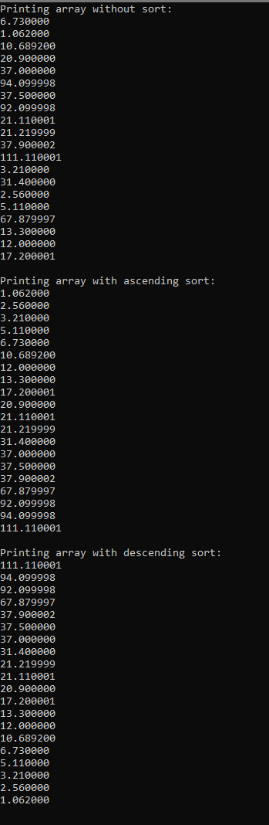The initial printed array is the array unsorted.

The second printed array is an ascending sort. The array still has 20 elements. There are no duplicated or changed elements, and each number is progressively bigger. The sort function was successful.

The third printed array is a descending sort. The array still has 20 elements. There are no duplicated or changed elements, and each number is progressively bigger. The sort function was successful.